TEACHER’S NOTES FOR PRACTICE 5:

1)The output is related to the tabs and lines in the xml, no matter how you write it, with the variable car, or with the for. It shows the same. To avoid it, use the replaceAll method.

@Override

**public** **void** characters(**char**[] ch, **int** start, **int** length) **throws** SAXException{

String car=**new** String(ch,start,length);

car=car.replaceAll("\t","");//cleans all tabs

System.***out***.print(car);

/*

if(lastElement==2){

for(int i=start;i<length+start;i++){

System.out.print(ch[i]);

}

}else if (lastElement==3){

for(int i=start;i<length+start;i++){

System.out.print(ch[i]);//¿could we do the same with one IF (lastElement==2 || lastElement==3)???

}

}

*/

//System.out.println();//change line.

}

NOTE: IF WE DON’T CLEAN THE TABS

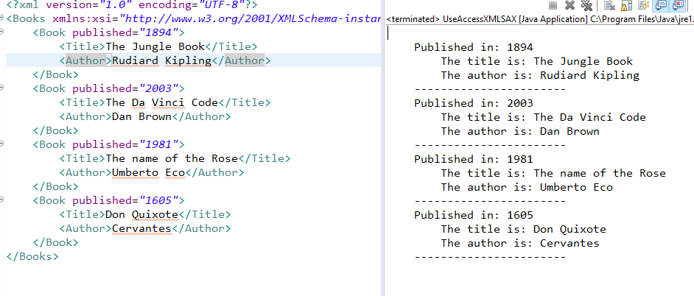

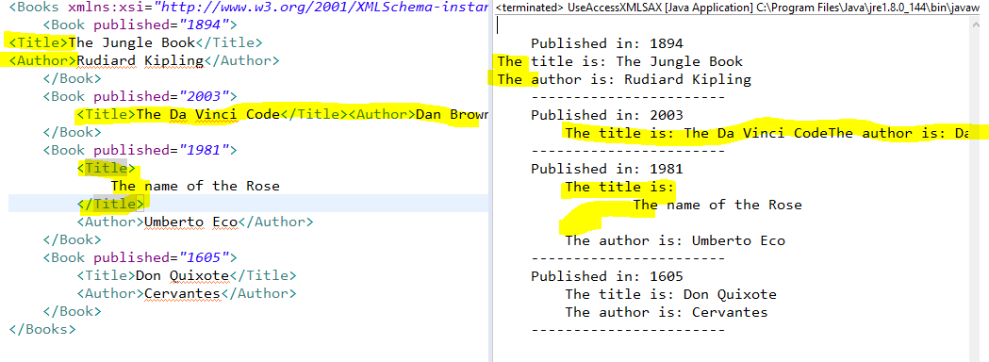

IF WE CLEAN THE TABS:

